Experiment No. 5
Roll No: B864
Aim: To implement & explore performance evaluation metrics for Data Models
Theory:
Performance evaluation metrics are essential for assessing how well a data model learns from training data and generalizes to unseen data. These metrics provide quantitative measures to compare different models and understand prediction errors. Depending on the type of problem, regression or classification, different evaluation metrics are used.

⮚ Regression Evaluation Metrics
Regression models predict continuous numerical values. The following metrics are commonly used: a) Mean Absolute Error (MAE)
MAE measures the average magnitude of errors between predicted and actual values, without considering their direction.
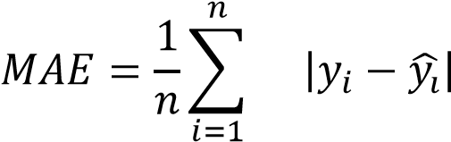
- Lower MAE indicates better model accuracy.
- It treats all errors equally.

b) Mean Absolute Scaled Error (MASE)
MASE compares the model’s MAE with the MAE of a naive baseline model.
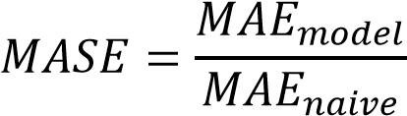
- A value < 1 indicates the model performs better than the naive approach.
- It is scale-independent and suitable for comparing models.

c) Mean Absolute Percentage Error (MAPE)
MAPE expresses prediction error as a percentage of the actual value.
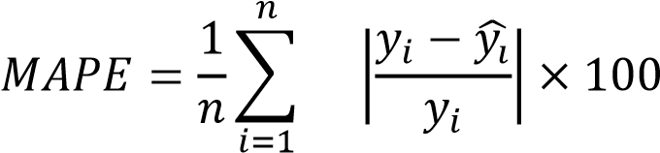
- Easy to interpret.
- Sensitive to very small actual values.

d) Root Mean Square Error (RMSE)
RMSE penalizes larger errors more heavily by squaring them.
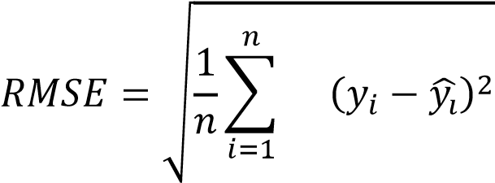
- More sensitive to outliers.
- Commonly used for evaluating regression models.
⮚ Classification Evaluation Metric
Classification models predict discrete class labels.

Confusion Matrix
A confusion matrix summarizes the performance of a classification model by comparing actual and predicted classes.
Actual \ Predicted | Positive | Negative
Positive | TP | FN
Negative | FP | TN
Where:
- TP – True Positive
- TN – True Negative
- FP – False Positive
- FN – False Negative
The confusion matrix helps derive metrics like accuracy, precision, recall, and F1-score, and provides deeper insight into model performance beyond simple accuracy.

Program & Output:
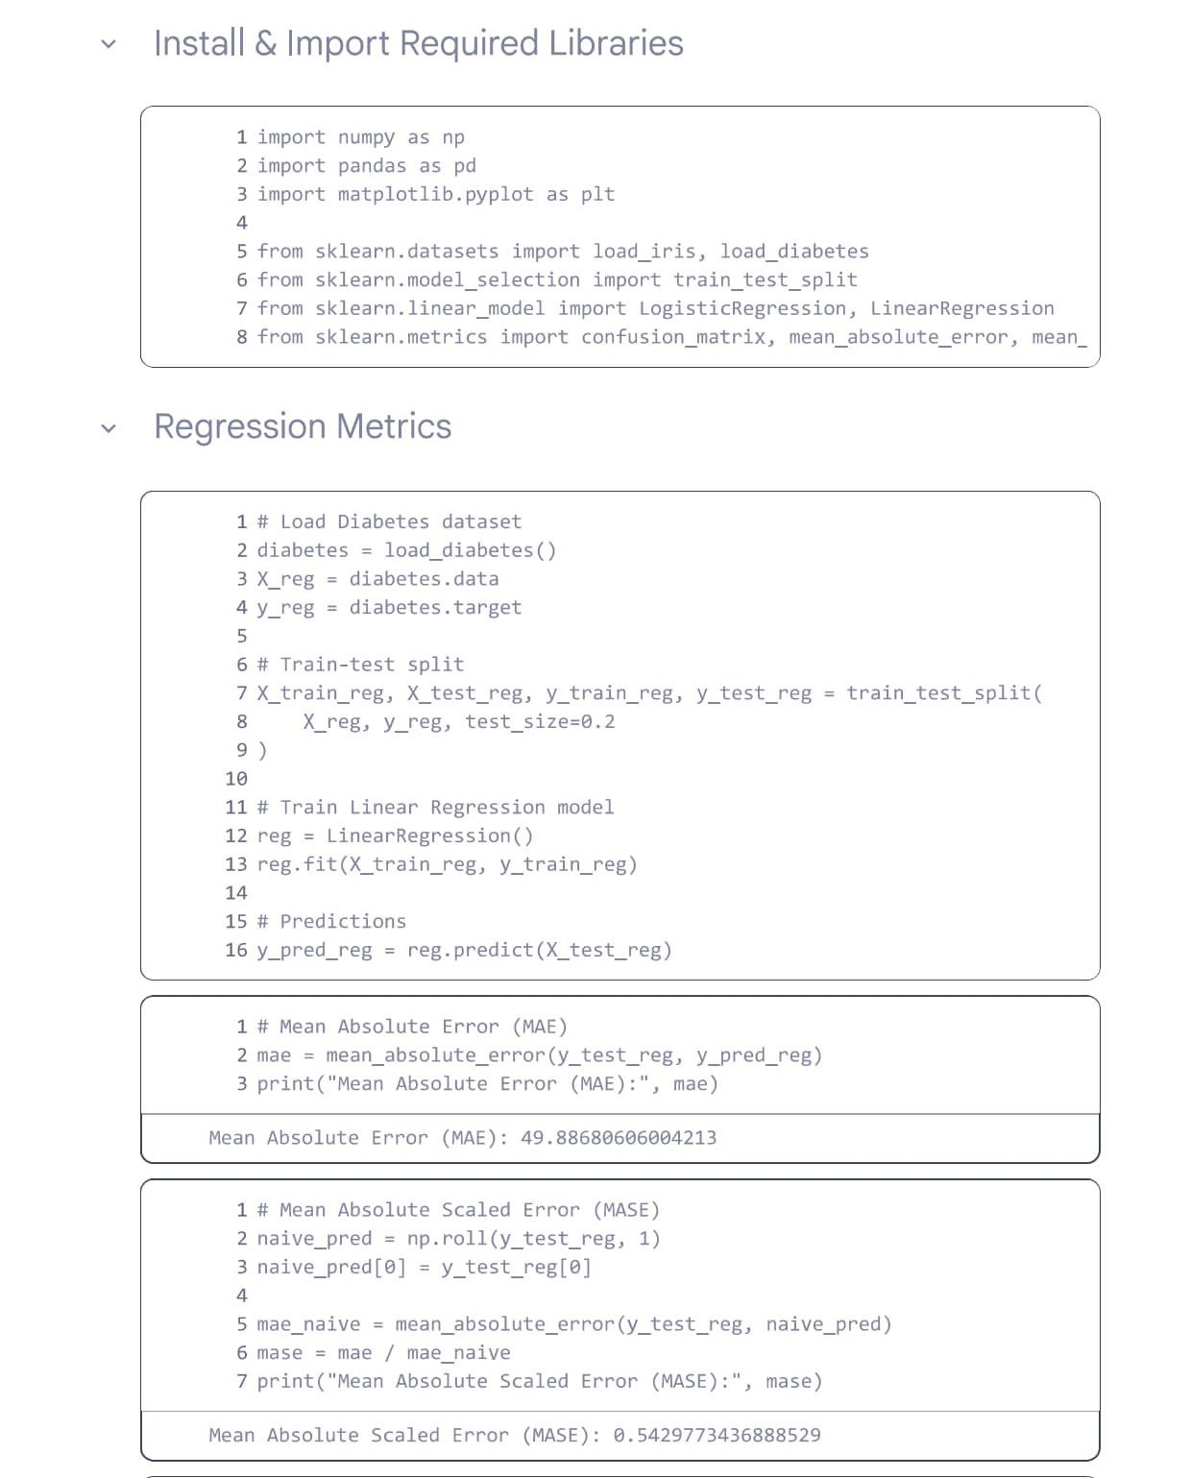

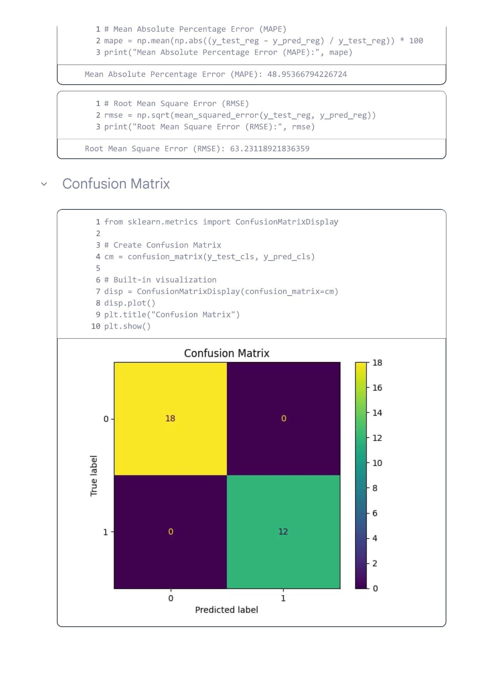
Conclusion:
In this experiment, various performance evaluation metrics were implemented and analyzed for both data models

